Part 1: 3D modelling w/ Fusion 360
If you want to use my design, you may use my files and skip forward to Milling, because I already did CAD and CAM.

Sketching: Just draw a simple Longboard shape. Don’t do a Regular street skateboard shape, because you cant do any shapes that are bent upwards (such as tails) . Since we’re later 3D milling it, it’s gonna be entirely flat. In my example it looked like this. 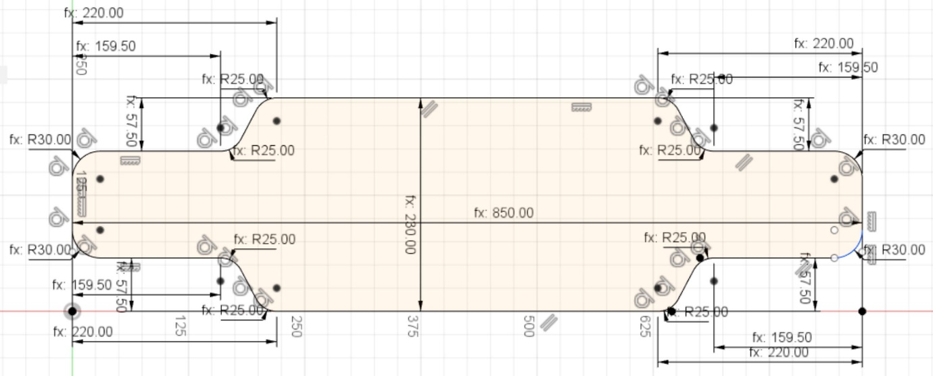
Modelling: First extrude it for like 18 millimetres (or your wood thickness if you’ve already bought it). You can later do minor adjustments, but 18 is certainly thick enough for Stability.
Second, Round out the edges. Don’t do slopes, because it will make the outer part of your Edge too thin and it will splinter if you step on it.
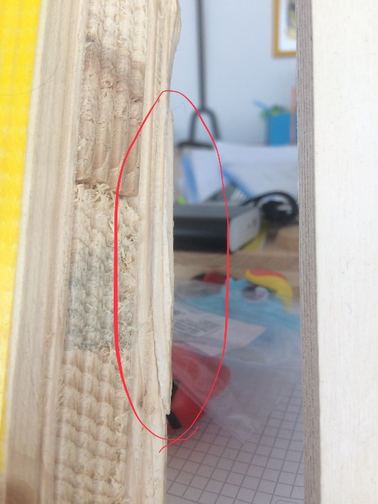
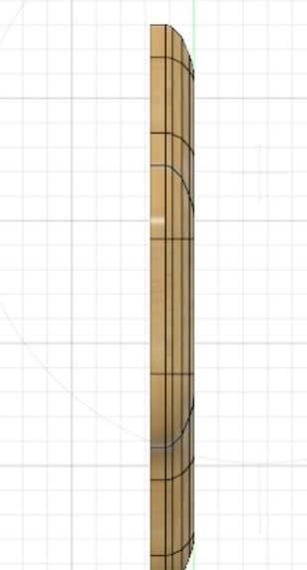
I really liked this edge profile and its never overly thin.
1: Encirculated splinter glued back on

Third, details. In my case, I added drop through holes and handles as you can see here.

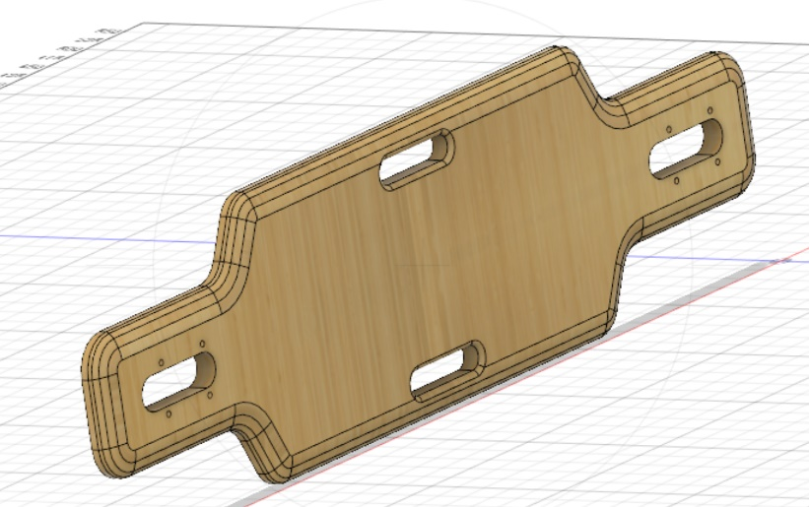
I decided to round the handle on the underside with the cnc mill and hand sand it on top, but you could aswell not cnc round the model edges and hand sand it on both sides.

Part 2: CAD and Milling
CAM: To get from your CAD to your CAM you need special Software. I used RhinoCAM. It’s a rather intuitive ( which means you still need a short training course) Milling Software, and the best one I’ve seen so far (I have tried Fusion360’s CAM software but know how to use it.) However, RhinoCAM requires a License that costs between 500 and 10’000 Dollars. I learned to use RhinoCAM and did my project at Fablab in Zürich, where you can use Rhino for free if you’re a member. The membership costs about 150 CHF annually, but they are a really nice, supportive community that sponsored me and also helped me a lot with this project. They also have 3D printers, hacked knitting machines and laser Cutters, so you get a lot of value for your money. I can’t explain CAM in this guide since that would take up a whole another guide. If you are able to use RhinoCAM or any similar CAM Software, just do a Roughing on the edges, then either use a parallel or a horizontal finishing (depending on what kind of pattern you want) and a Profiling to cut it out. Don’t forget bridges, in order to keep your part from flying around in the cnc mill and possibly damaging it, your mill-bits and the machine. The engraving, as I said is optional.
Wood: I advise using plywood, because it offers the best possible stability, but sadly, it has no flex at a thickness around 18 mm. If you want some flex and/or a thinner board, you will need to get actual skateboard wood.
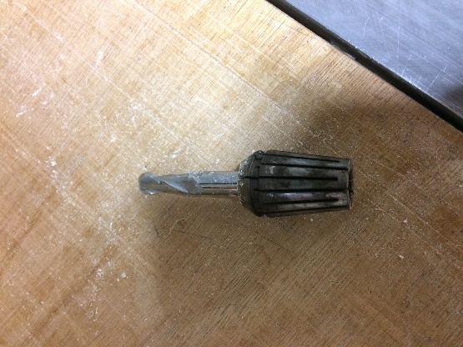
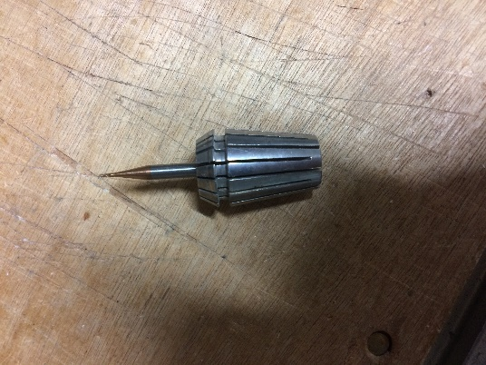
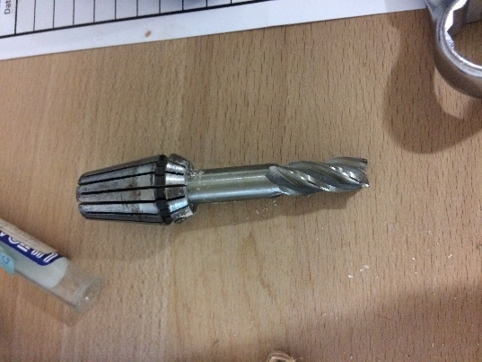
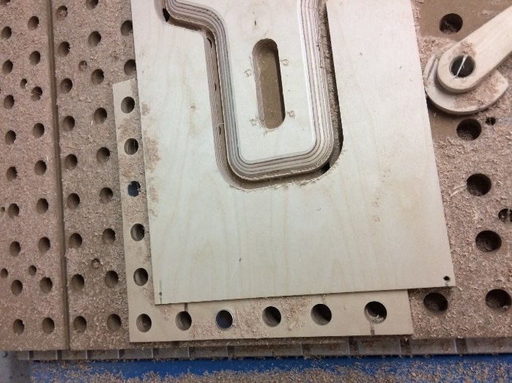
Milling: You can learn to mill at the same one day training course at Fablab Zürich I mentioned above. They also have a great fixation system. If you already know how to mill, this part is pretty simple. (If you are at this point using my files, run through the exported .nc files in the order they’re numbered) You just need one Flat mill (I used a 10 mm flat mill) for the Roughing and Cutting, and one round mill (otherwise referred to as ball mill) (I used an 8 mm ball mill). I also used a small 1 mm round mill for engraving little circular marks, where the screws of my trucks should go, but they were misplaced so I ended up just using the baseplate of my trucks as a drilling template, which is probably the easiest and best solution in retrospective.
Part 3: Design and Finishing
Finishing: As for finishing, you need to remove the bridges (the little parts that remain after separating the board, which fix it to the stock), then sand it where the little stubs are. Also you need to sand the edge where it was cut. Just sand until you find it good. Also roughen the surface just a little bit with some fine sandpaper, to allow the varnish to stick better to the surface
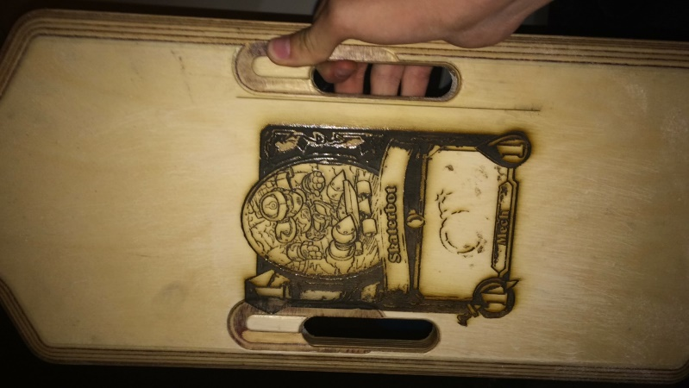
Underside design: Underside design is pretty individual. I decided to add a laser engraving, which is pretty simple, because you just need a black and white image either as a PDF, a JPG or a BMP. However, you need to look out for three things when doing an engraving. First, avoid grey tones, as they are, depending on the darkness, either seen as black, thus resulting in an entirely black image, or as white and thus completely ignored by the laser. Second, watch out for thin, easy to overlook black lines on the picture borders, because they will later appear on the Laser engraving, resulting in something looking like this. Third, center your graphic in the middle of your image, so when you center your image, the graphic is actually centered on your Longboard. Third, upload it in in your software and put it and your wood so that it is properly placed. You can see the starting point, where the laser is pointing at, on the work surface (at least on the AKJ 6090) Other than that, you need to find the right Balance of Power and speed on your laser, which is of course different on every laser, with some test runs on scrap wood. I used an AKJ 6090 at Fablab Zürich with RdWorks and settings as seen on the picture below, (min and max power 25, speed 200.)
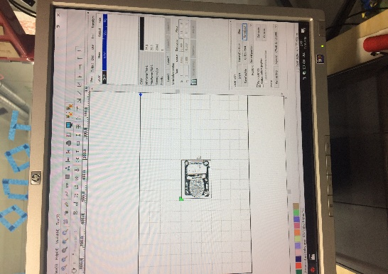
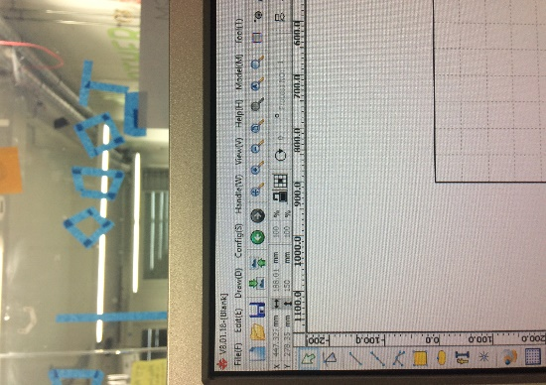
You can of course also paint the underside, this is really up to you.

If you decide leave the underside blank, laser engrave something or leave any naked wood, you need to put some lacquer on. I used synthetic resin varnish, which I cannot recommend in retrospective, you need pretty nasty chemicals (universal diluent) to wash your brush and it needs very long to dry. You might want to try acrylic laquer, but I haven’t tried that myself yet. However, if you decide to use synthetic resin varnish, try putting the lacquer on in multiple thin layers, for the burnt wood doesn’t absorb very well and the grooves from the laser fill up with varnish very easily, resulting in thick, very slow drying layers. Also a very dry, well ventilated room at a temperature of 18-25 degrees accelerates the drying process.

